Exercise 1.2 Insertion-Sort:
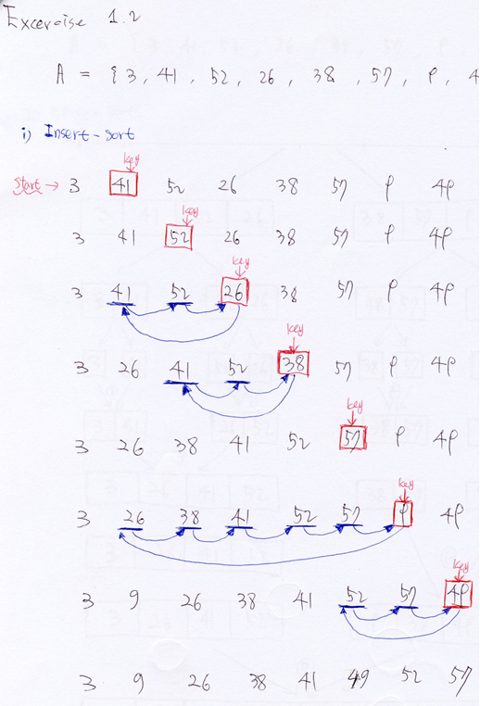
Exercise 1.2 Merge-Sort:
